2024 - 2050 Population Growth Forecasts

The Mid-Ohio Regional Planning Commission (MORPC) is Central Ohio’s regional council for more than 80 local governments and community partners across 15 counties. MORPC takes pride in bringing communities of all sizes and interests together to collaborate on best practices and plan for the future of our growing region, while reaffirming the commitment to address inequalities and barriers to eliminate systemic racism. MORPC accomplishes this through a variety of programs, services, projects, and initiatives—all with the goal of improving the lives of everyone throughout the Central Ohio region.
Elemental to that role, MORPC is committed to engaging in ongoing, objective evaluation of regional trends and changes at the state, national, and even global scale that impact our growing region. The methods selected for producing MORPC’s updated population growth forecasts are based on research and subjected to rigorous testing and ongoing evaluation. More specifically, these forecasts are based on the best available data and sound modeling techniques, with confidence limits to convey how forecasts could change over time if key assumptions change.

Regional Growth Forecast Data Points:
- The 15-county Central Ohio region is on track to reach nearly 3.15 million residents by 2050, a small uptick from previous projections.
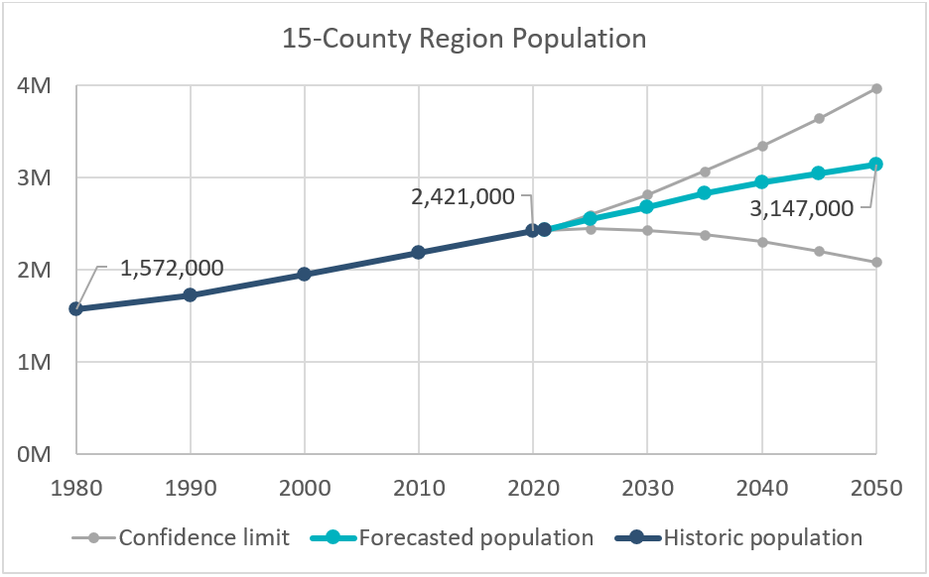

- Over the course of the next 25+ years, the Central Ohio region will see a growth of 726,000 people, which equates to 272,000 additional households and 357,000 additional workers.

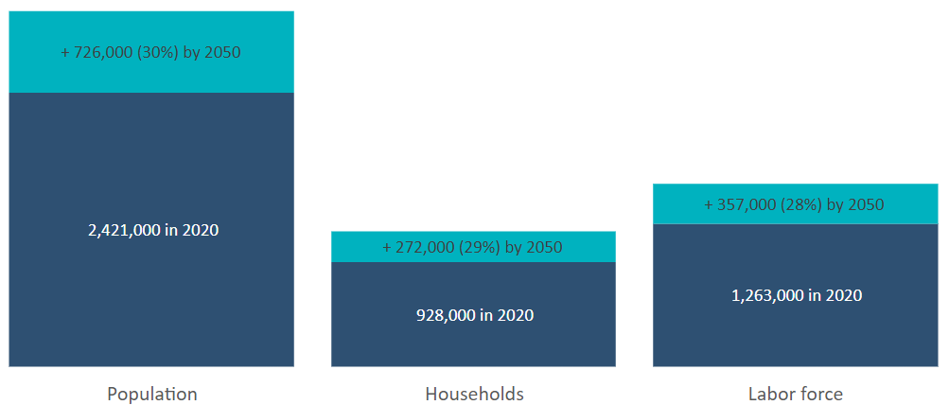

- Births and people moving to Central Ohio (in-migration) were almost equally contributing to the region’s growth in the past. However, Central Ohio, like the nation, is showing a continued trend of increased death rates and lower birth rates. This trend is in part due to our aging population, making it even more important to welcome new people to our region.
- According to a report commissioned by the Building Industry Association (BIA) of Central Ohio, housing permitting must increase approximately two-fold from recent trends to meet the projected housing need of over 100,000 new housing units in the next decade. It is more important now than ever to ensure that a variety of attainable housing options will be available to accommodate these new residents, and that market demand for more walkable neighborhoods is being met., By working together, the Columbus region can remain competitive and keep its relative housing affordability compared to other metro areas.
- Franklin County is expected to absorb half of the regional growth and will welcome more than twice as many newcomers as the next-highest county (Delaware). That said, the six surrounding counties will experience greater growth relative to their current populations ranging from a 30% increase (Madison and Licking) to 80% (Delaware), compared to 26% for Franklin County.
- Our recent growth places us among the fastest-growing large metros in the country. We are growing faster than any other region in the state, but at an estimated 0.89% annually, it is a much more manageable rate than metros, such as Austin or Boise, which have been growing at twice the rate of Central Ohio.
- Our region’s strong growth can be attributed, in part, to continued strong economic development. Although MORPC does not attempt to predict which firms will choose to establish operations in Central Ohio, our forecasting process anticipates development-induced growth, and plans for it. Communities must work to attract, retain, and develop firms that amplify existing industry clusters, produce jobs in a variety of pay ranges, and support an increasingly diversified talent pool.
- More than 80% of Central Ohioans enjoy a commute time of less than 35 minutes to work If communities wish to preserve this convenience as the region continues to grow, they must strive to develop housing near jobs and jobs near housing, locating new developments within close proximity to transit routes whenever practical. Thoughtful land use planning is also critical to improving air quality, reducing greenhouse gas emissions, and protecting our rivers and lakes from chemical runoff and stormwater impacts.

For additional insights about expected changes to population, housing, and employment in Central Ohio counties, please refer to www.morpc.org/popforecast. For questions, please email dataandmaps@morpc.org.

Unless otherwise stated, facts in this document are drawn from MORPC’s 2024-2050 County Population Forecasts spreadsheet, available from our Population Resource Hub. https://experience.arcgis.com/experience/cd446109151f474db74b13fa0795023c/
Derived from mortality and birth statistics, 2010-2021, Ohio Department of Health
Analysis of Housing Need for the Columbus Region, Vogt Strategic Insights, 2022, p. II-2
Regional Housing Strategy Final Report, MORPC, 2020
2020 Community & Transportation Preference Survey, National Association of Realtors, October 2020
Derived from data from the Census Population Estimates program over the period 2010 to 2021. Compound annual growth rate (CAGR) for the Columbus CBSA is rank 25 of 77 areas that comprise of the top 20% of CBSAs in total population. CAGR for Columbus, Austin, and Boise is 1.10%, 2.85%, and 2.23%, respectively.
Table B08012: Travel Time to Work, 2017-2021 American Community Survey 5-year Estimates, U.S. Census Bureau

